**Task: Implement a Drag and Drop File Upload Component**

**Description:** You are tasked with implementing a drag and drop file upload component using Node.js and React.js. The component should allow users to drag files from their computer and drop them onto a designated area to upload them. After uploading, the component should display the uploaded files and provide options to view, download, or delete them. Uploaded files must be recorded in the Mongodb database. **You must have implemented the below technology stack requirement in your assignment project.**

**Requirements:**

#### **Technology stack:**

* Frontend:
  + React.js, React Redux, Redux Form, Bootstrap, Html, Css, Javascript, Jquery
* Backend
  + Nodejs, Express.js
* Database:
  + Mongodb
* **User Interface:**
  + Design and implement a visually appealing user interface using React.js.
  + Create a drop zone area where users can drag and drop files for upload.
  + Display the uploaded files with their names, file sizes, and icons representing their file types.
  + Include options to view, download, or delete uploaded files.
* **File Upload and Storage:**
  + Implement server-side file upload functionality using Node.js.
  + Handle the file upload process securely, validating file types and sizes.
  + Store the uploaded files on the server or integrate with a cloud storage service (e.g., Amazon S3).
* **Drag and Drop Functionality:**
  + Implement the drag and drop functionality using HTML5 Drag and Drop API or a suitable library.
  + Allow users to select files through a file browser dialog as an alternative to dragging and dropping.
* **File Management:**
  + Implement the ability to view uploaded files, including generating thumbnail previews if applicable.
  + Provide options to download or delete uploaded files.

**Sample preview of upload and list files:**

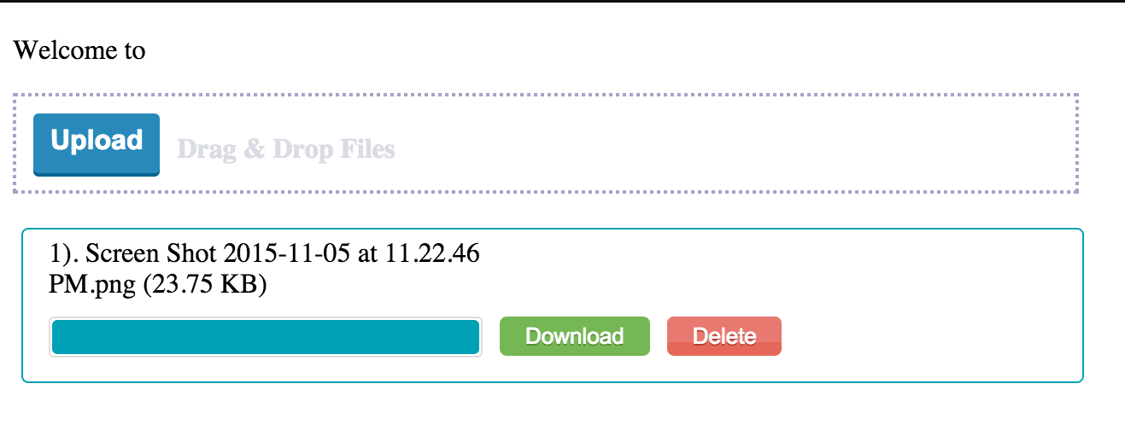

**Guidelines:**

* Use the latest stable versions of Node.js and React.js.
* Utilize appropriate libraries or frameworks for drag and drop functionality (e.g., React DnD, Dropzone.js).
* Write clean and well-structured code, following best practices.
* Pay attention to user experience, ensuring the component is intuitive and responsive.
* Include clear instructions on how to run the application locally and any additional setup requirements.

**Evaluation Criteria:**

* You will be evaluated based on the following factors:
* Functionality: Does the component meet the specified requirements?
* Code Quality: Is the code clean, well-structured, and maintainable?
* User Interface: Is the UI intuitive, visually appealing, and responsive?
* Drag and Drop Implementation: Is the drag and drop functionality implemented correctly?
* Overall User Experience: How seamless and enjoyable is it to use the component?

**Submission:**

Please provide the following for evaluation:

* Source code of the component (preferably in a Git repository).
* Any necessary instructions or documentation required to run the component.
* (Optional) A brief summary of your design decisions, challenges faced, and improvements you would make given more time.